

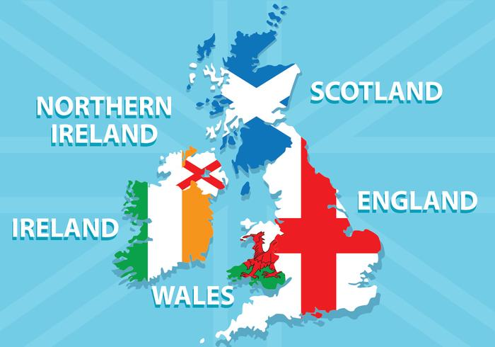

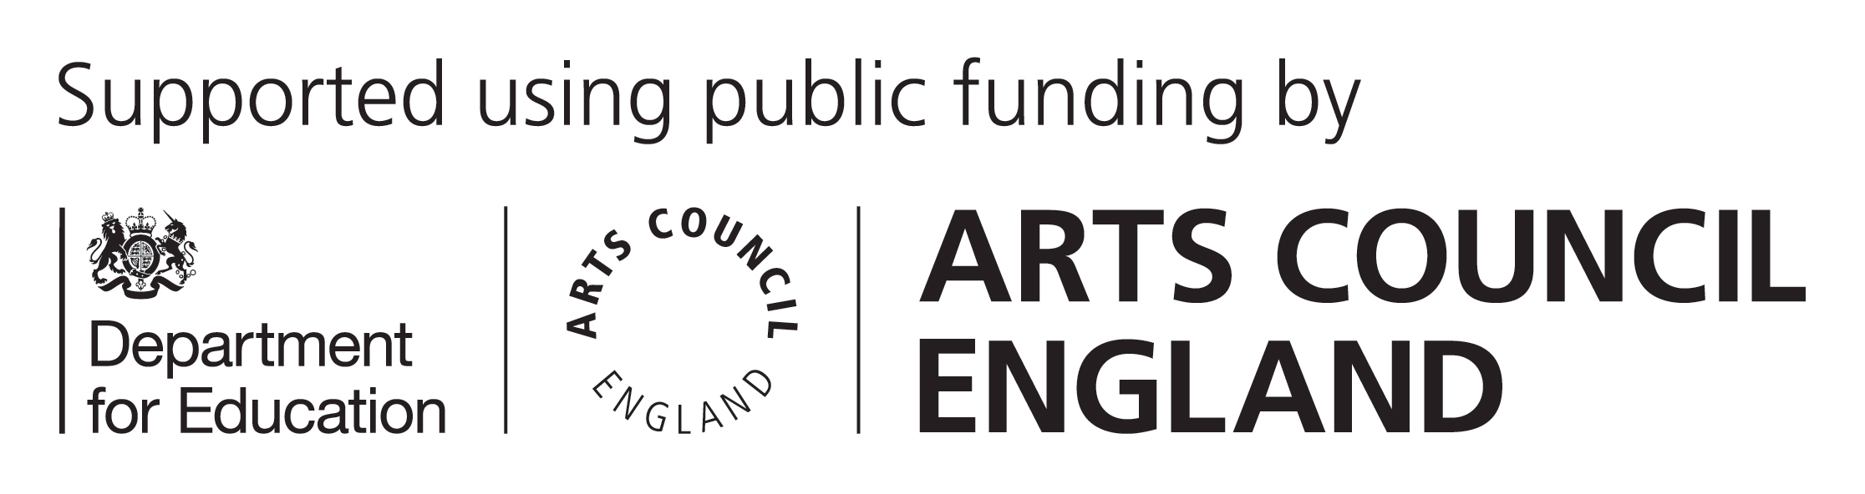

Swindon Music Service
in Association with Swindon Schools Present:
Songs from Around
the British Isles
Junior Voice Festival March 14th and 15th Performances 4:45 and 7:30pm
Wyvern TheatreTickets from Wyvern Box Office:

