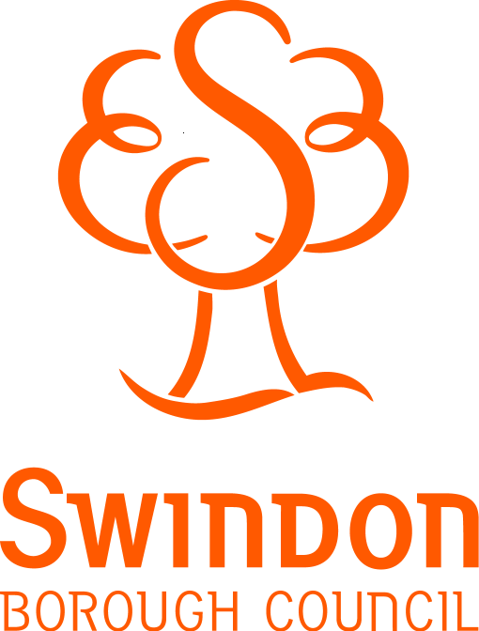

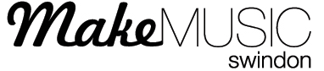

Swindon Music Department

Commissioning
The Platform
Faringdon Road
Swindon, SN1 5BJ
Tel: 01793 401754
www.makemusicswind.org

Please ask for: Lynn Hawkins
e-mail: Lhawkins2@swindon.gov.uk

Our ref: JLH/MaN 02

Date: 3rd January 2017
- Tickets
To be sold direct to parents via the ‘The Wyvern Box Office’ at £2.50 full price and £concessions per ticket. Tickets can be purchased either by phone or on the Wyvern Theatre website. (They will not be on sale until I have all your confirmation of dates) I’ll inform you via email).

PLEASE STRESS:
Tickets can ONLY be purchased FROM THE WYVERN (NO TICKET SALES from the PLATFORM). Tickets will be sold on a First come First served basis. Phone 01793 524481 Or, Online www.swindonthratres.co.uk - Click on the [Book Now] Link. Or, you can buy your tickets in person at the Wyvern Box Office. Purchases through either method can be paid via Credit or Debit card (Cash or Cheque can only be used if buying tickets in person from the Wyvern).

You will need to inform parent/carers of which performance date your children will be performing, before they can purchase their tickets.

Your role is to inform parents/carers of this opportunity and to outline how and when they can obtain tickets. This could be achieved through school Newsletters, Websites or any other communication processes you may have to inform parent/carers of any information.

- VIP Tickets
Each School will be allocated two VIP tickets FOC. These will be for the performance that your School performs. However you must pre-book them with me, or they will not be reserved.

For further information about any of the above, please contact me: Lynn Hawkins Lhawkins2@swindon.gov.uk or 01793 401754

Yours Sincerely
Lynn Hawkins
Make Music Swindon

