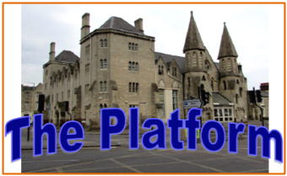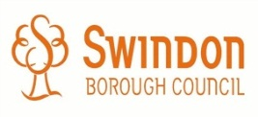

The Platform

Access Statement

Date: 1st June 2017

Author: Director Swindon Music Service

Review Date: June 2018
Swindon Music Service aims to provide accessible access for all, volunteers and members of the public.  1. Location and Access  The full address of The Platform is,  The Platform  Faringdon Road  Swindon  SN1 5BJ  Telephone No: 01793 864891  Opening Hours: Monday to Friday 9.00am to 5.00pm | 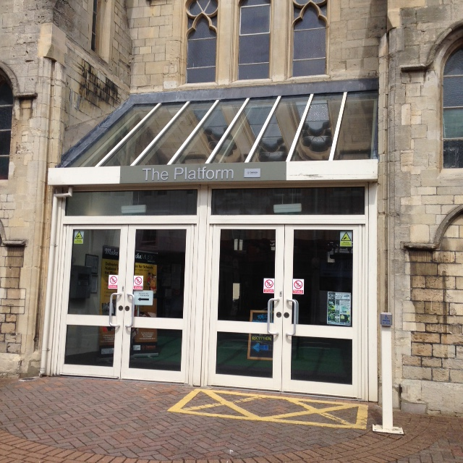

2. Getting to The Platform

The Platform is located in the centre of Swindon on Faringdon Road. It is on the Cross Road of Faringdon Road, Emlyn Square and Farnsbury Street.

Bus
The closest bus stop is on Farnsby Street at Canal Walk is approximately 250m level paved route. Services 1/1A, 13, 14, 18 and 19 stop here every 10 minutes on weekdays. These are all low floor buses.
Services from rural areas come to Swindon Bus Station – approximately 550m. Follow signs to the “Shopping Centre”. Fleming Way, which has stops for all town centre bus services, is approximately 400m away. The level pedestrian route is via The Parade to Canal Walk.

Train

Regular train services stop at Swindon Railway Station – approximately 700m. Follow signs to the “Shopping Centre”, and then join the level pedestrian route via The Parade to Canal Walk.

Car

The closest covered car park is Brunel South and the entrance is on Farnsby Street. Marked blue badge bays for Disabled people give direct access to the first floor of the Brunel Shopping Centre.

There are two marked blue badge bays in the Queen Street Car Park. This is free for cars displaying a blue badge. This car park is approximately 750m from the main entrance to The Platform. This includes a steep incline (1:10 over 20m) with some handrails (100cm high) to access the Brunel Centre. There are also two marked blue badge bays in East Street 500m from The Platform.

4. The Platform Main Entrance

The main entrance to The Platform is from Faringdon Road. As you face the building it is in the centre and the staff entrance is on the far left hand side. The public entrance is sign posted as “The Platform”. The right hand glass doors open outwards using a push button positioned on a post 1.2mtr from the door and 1.2mtr from the ground
This gives access to The Platform Reception area and main Hall when activities are running. All other access is through the intercom system outlined below

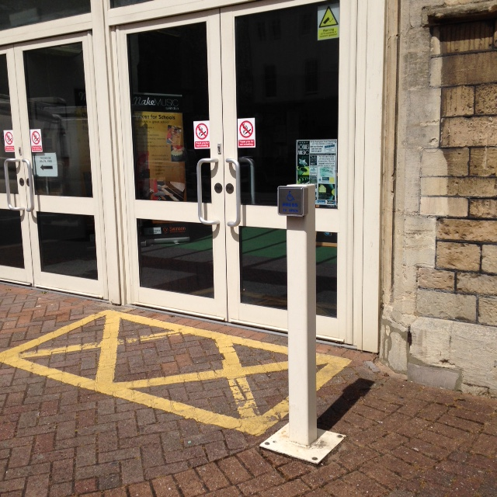

An intercom system is situated to the left hand side of The Platform right on the outside of The Platform staff entrance, and it is 1.4 metre from the ground. The intercom is for access during the working day.

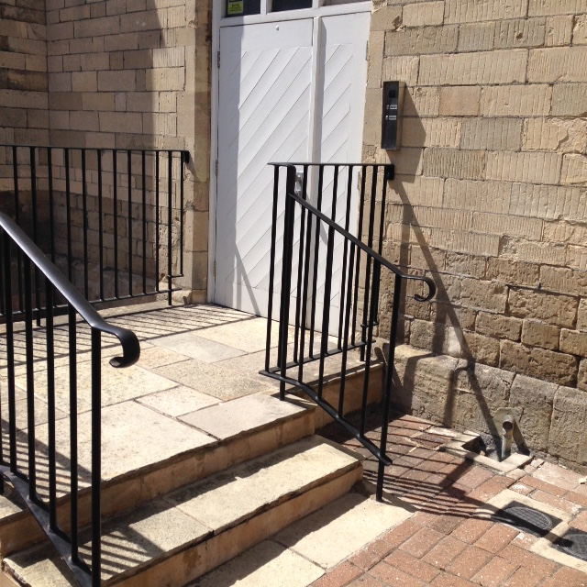

5. Normal working day opening hours
The opening hours for the Platform reception are Monday to Friday 9.00am to 5.00pm. An induction hearing loop is fitted to the reception desk. Please stand close to the loop sign and switch your Hearing Aid to the ‘T Position’.

6. Toilet, Baby Change and Medical Facilities
Access to the Platform ground floor toilets, disabled toilet and assisted medical room are from the main hall using a slope to main corridor.
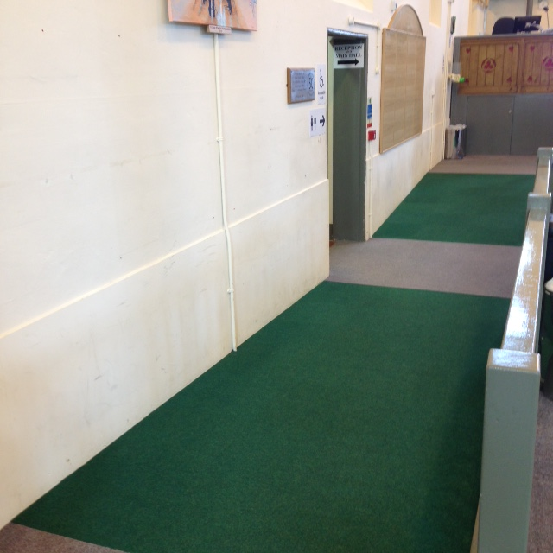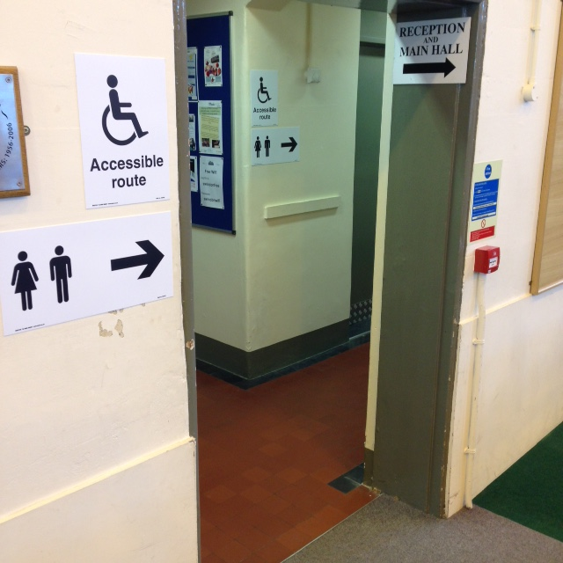
The assisted medical room is accessed through two manually operated doors.
The assisted medical room contains a Guldsman 200kg hoist, and an adjustable height Plinth 2000 bed.
It also has baby change facilities, sharps bin, sanitary waste bin and a sink.
The first floor of the Platform also has single room ladies and gentlemen’s toilet facilities.

.

7. The Platform Car Parking
Bristol Street Car Park closes at
11pm. £1 for 2 hours, £2 for 4 hours The Platform Blue Badge
and £3.50 all day Parking

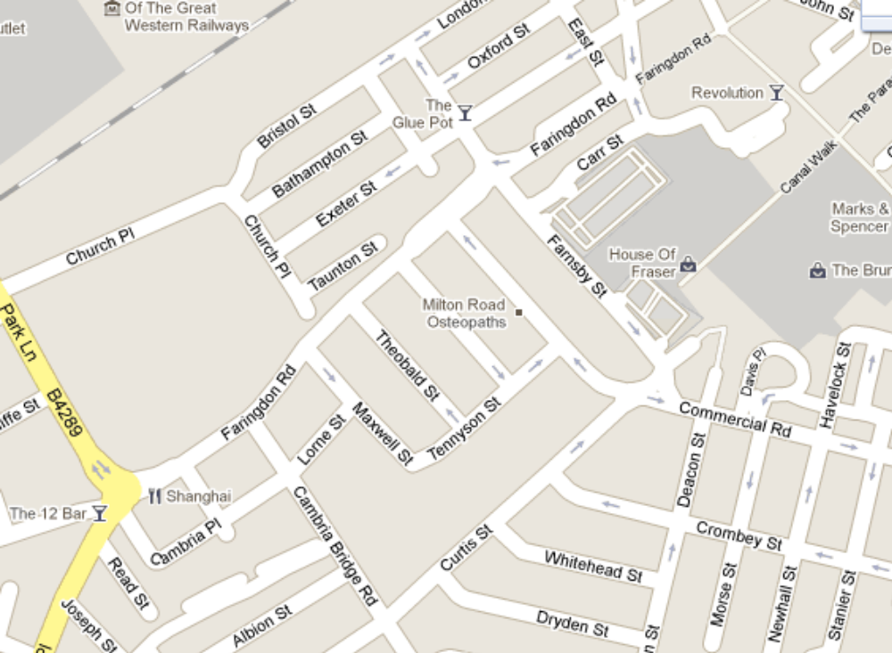

Brunel North Multi Storey Closes 9.00pm Brunel West Multi Storey Open 24
Monday to Saturday and 5.00pm Sundays. Hours. £2 for 4 hours and £1.80 for
£2 for 4hours and £1.80 for night rate night rate 6.00pm to 6.00am
6.00pm to 6.00am.

Please Note: The streets around the Platform
offer free parking after 6.00pm

8. Emergency Escape

In the unlikely event of an emergency, The Platform will be evacuated using the nearest emergency escape route.
The emergency escape procedures will be explained to all staff and members of the public if they require access to the first floor office area.
All users of the building attending public meetings will be advised of the emergency evacuation procedures. Responsibility for undertaking this lies with the meeting organiser.
Information about the fire evacuation procedures is available at The Platform reception desk.
The Platform fire assembly point is located at the front of The Platform outside number 26 Faringdon Road.

9. Commitment to Access

We at Swindon Music Service are committed to making sure those services and rooms are available and accessible to all members of the public. No one will be excluded from The Platform because of poor physical access to The Platform building.
We recognise that The Platform is not fully accessible. However The Swindon Music Service is committed to ensure measures are in place to minimise physical barriers to using the building and benefiting from the services that Swindon Music Service provides at the Platform.

