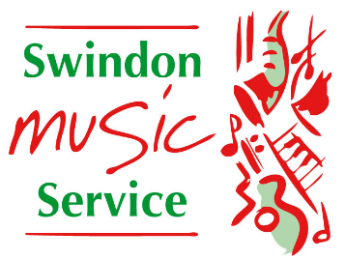
Access and Participation Statement
As the lead organisation of the Swindon Music Education Hub (Make Music Swindon) Swindon Music Service is responsible for providing students from across the borough with opportunities to access high quality, out of school ensemble and progression opportunities. In addition, we work with schools, Hub Partners and a diverse range of other organisations to provide performance opportunities throughout the year and offer an Access Fund to those students experiencing financial or personal hardship.
Swindon Music Service’s guiding principles:
Serial | Description
1. | To place young people’s needs at the centre of our decision-making and service development
2. | To map and facilitate pathways for progression and practice development across a range of genres, from early years onwards, in response to our particular local needs
3. | To minimise financial, geographical and personal barriers to participation
4. | To enable young people to make a positive contribution to society through participation
5. | To raise aspirations by enabling young people to enjoy inspirational events
6. | To build in legacy and develop capacity wherever appropriate
7. | To strengthen links between partner organisations at all levels from strategic to operational
8. | To communicate effectively and share information and good practice
9. | To encourage creativity and innovation within music education

