Child Protection Policy for Community Organisations working at the Platform
Contents
1.  2.  3.  4.  5.  6.  7.  8.  9 | Policy Statement  Procedures for Referral  Alleged abuse by Staff, Managers, Volunteers  Record Keeping  Parental Involvement  Training  The Role of the Management Group  Review  Further Information | Page(s)  2 / 3  3  3 / 4  4  4  4  4  5  5

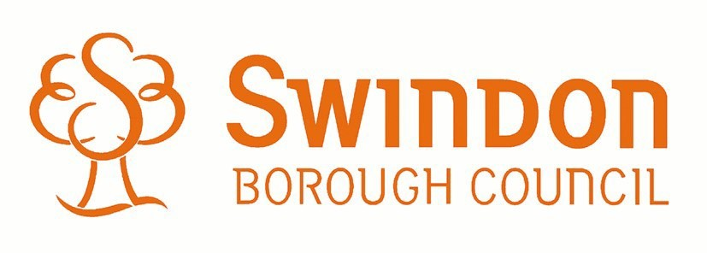

Child Protection Policy – (The Platform)
1. Policy Statement
We believe that it is always unacceptable for a child or young person to experience abuse of any kind and recognizes its responsibility to safeguard all children and young people and promote their welfare, by a commitment to practice which protects them.
We recognize that:
- The welfare of a child/young person is paramount.
- All children, regardless of age, disability, gender, racial heritage, belief, sexual orientation or identity, have the right to equal protection from all types of harm or abuse.
- Working in partnership with children, young people, their parents, carers and other agencies is essential in promoting young people’s welfare.
The purpose of the policy:
- To provide protection for the children and young people who receive Music Services through Swindon Young Musicians.
- To provide staff and volunteers with guidance on procedures they should adopt in the event that they suspect a child or young person may be experiencing, or be at risk of, harm.
The policy applies to all staff, including senior managers, paid staff, volunteers and essential workers, agency staff, students or anyone working on behalf of Swindon Young Musicians
We will seek to safeguard children and young people by:
- Valuing them, listening to and respecting them
- Adopting child protection guidelines through procedures and a code of conduct for staff and volunteers.
Recruiting staff and volunteers safely, ensuring all necessary checks (including DBS checks) are made
- Sharing information about child protection and good practice with children, parents, staff and volunteers.
- Sharing information about concerns with agencies who need to know, and involving parents and children appropriately.
- Providing effective management for staff and volunteers through supervision, support and training.
We are also committed to reviewing our policy and good practice annually.

2. Procedures for referral
2.1 All action is taken in line with the following legislation/guidance:
- South West Safeguarding and Child Protection Shared Procedures, www.swcpp.org.uk
- Safeguarding Children in England September 2004
- Working Together to Safeguard Children 2006
- What to do if you’re worried a child is being abused 2006
2.2 Any members of staff or volunteer who receives a disclosure of abuse or suspects that abuse may have occurred must report it immediately to the designated person for child protection: Dougall Prophet, or if unavailable to the Head of SYM: Lynn Hawkins. In the absence of either of the above, the matter should be brought to the attention of the most senior member of staff.
2.3 The designated person will immediately inform Children Services Referral Team by telephone: Telephone number 01793 466903 Out of hours telephone number: -1793 436690
2.4 The telephone referral to the Children Services Referral Team will be confirmed in writing using the form marked RF1, within a maximum of 48 hours, ideally 24 hours, with a copy to the designated person for child protection: Dougall Prophet. Essential information will include pupil’s name, address, date of birth, family composition, reason for referral, name of person receiving the referral and any advice given. This written confirmation must be signed and dated by the referrer.
2.5 Confidentiality must be maintained and information relating to individual children and young people/families shared with staff on a strict need to know basis.
3. Alleged Abuse by Staff, Managers, Volunteers
3.1 When an allegation is made against a member of staff or volunteer, then the allegation must be passed to the designated person for child protection: Dougall Prophet or their deputy: Lynn Hawkins, or, if the allegation concerns them both, direct to the Local Authority Designated Officer (see below).
3.2 Our designated person for child protection (Dougall Prophet) will contact one of the Local Authority designated officers for consultation
- Local Authority Designated Officer, on 01793 466849
- Head of Safeguarding on 01793 464366
- The designated officer contacted will record a note of the consultation and will advise on the appropriate action that needs to be taken.
4. Record Keeping
4.1 Any member of staff or volunteer receiving a disclosure of abuse, or noticing possible abuse, must make an accurate record as soon as possible noting what was sais or seen, putting the event in context, and giving the date, time and location. All records must be dated and signed.
4.2 All hand-written records will be retained, even if they are subsequently typed up in a more formal report.
4.3 Written records of concerns about children should be kept, even where there is no need to make a referral immediately.
4.4 All records relating to child protection concerns will be kept in a secure place and remain confidential.
5. Parental Involvement
5.1 This organisation is committed to helping parents/carers understand its responsibility for the welfare of all children and young people.
5.2 Parents/carers will be given information about the organisation’s child protection procedures.
5.3 Where possible, concerns should be discussed with parents/carers and the designated person should seek agreement to make a referral, unless to do so would place the child/young person at increased risk of significant harm.
6. Training
6.1 The designated person and his deputy must receive training every 2 years in child protection. Training is available from Swindon Local Safeguarding Children Board www.swindonlscb.org.uk tel: 01793 463803
6.2 All staff and volunteers shall have access to appropriate training on a regular basis, at least every 3-years.
7. The role of the management Group
7.1 Our designated officer for child protection (Dougall Prophet) will provide an annual report on changes to child protection policy or procedures; training undertaken by the designated person, other staff, volunteers, the number of child protection incidents/cases (without detail or name); and the place of the child protection issues in planning.
8. Review
8.1 This policy will be reviewed on an annual basis, and updated where appropriate

Date of Review is: January 2018
Further information
For futher information abouy what to do if you are worried a child is being abused, see the Swindon LSCB website: www.swindonlscb.org/lscb-index/lcsb-workers-home/lcsb-workers-whattodo.htm
Leaflets available from Swindon LSCB also include:
- Copies of the DfE summary booklet What to do if you are worried a child is being abused
- Credit card sized leaflets entitled Workers’ Pocket Guide, which can be carried for easy reference
The South West Safeguarding and Child Protection Shared Procedures cn be accessed at: www.swcpp.org.uk

Form RF1 is available for download from Swindon LSCB website at www.swindonlscb.org.uk/lscb-index/lcsb-wokers-home/lscb-wokers-forms.htm or by telephoning the Children Services referral Team

