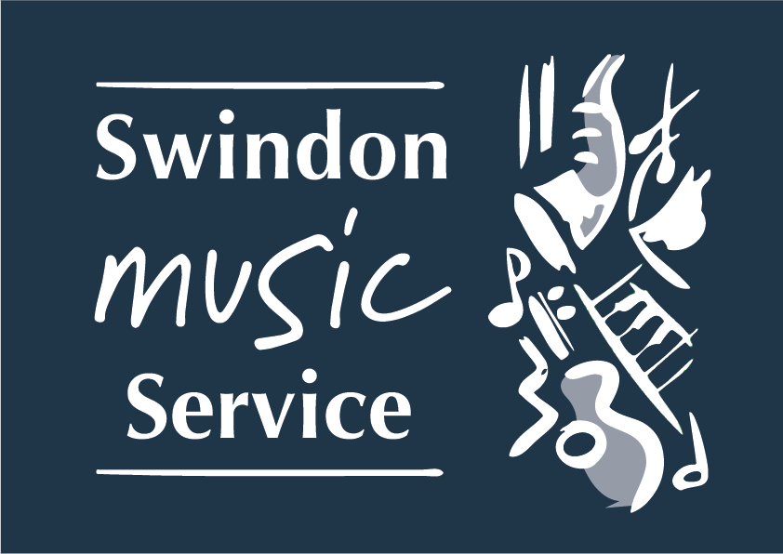

Website: www.smscio.org

Junior Voice Festival
CARNIVAL!
Wednesday 18th & Thursday 19th March 2020
General Guidelines

- Choir Number restricted to 22 per school

- Your Performance Date:………………………. Time……………………………

- Performance 1. (FIRST PERFORMANCE):
Please arrive at the Wyvern as close to 3:10pm as possible for a prompt start to the rehearsal at 3:30pm. On arrival, please go direct to STAGE DOOR sign in and go straight to the stage. Your helpers may take any belongings to your designated Dressing Room. NO Packed tea, is required for ANY of the performances.
- The rehearsal will finish at around 4:15pm. Children and staff will then be free for a COMFORT BREAK ONLY.
- 4:35pm – Choirs take position as directed.
- Concert 1. starts at 4:45pm (finishing around 5:35pm)

- Performance 2. (SECOND PERFORMANCE):
Please arrive at the Wyvern as close to 5:50pm as possible for a prompt start to the rehearsal at 6:15pm. On arrival, please go direct to STAGE DOOR sign in and go straight to the stage. Your helpers may take any belongings to your designated Dressing Room. NO Packed tea, is required for ANY of the performances.
    - The rehearsal will finish at around 7:00pm. Children and staff will then be free for a COMFORT BREAK ONLY.
    - 7:15pm – Choirs take position as directed.
    - Concert 2. starts at 7:30pm (finishing around 8:15pm)

Please can I ask you to:
- Confirmed your Choir Numbers ASAP
- Booked your Head Teacher and COG seats (if required)
- Let me know your Chaperone list ASA

- Please bring the following items with you on the performance day:

    - Register
    - Emergency contact names and telephone numbers
    - Small first aid kit
    - Spare toilet rolls, wet wipes, etc.

- Dress:
    - Children should be encouraged to dress for Carnival (as outrageous as possible).
    - Try not to have big head pieces or hats please.
    - please advise children not to bring coats as there is nowhere to store them

- It is important to stress to your parents that we are in a professional theatre and NO PHOTOGRAPHY or RECORDINGS will be permitted. Schools should arrange their own photographs separately. This of course, will be announced at the events.

- Your Role
- All staff are responsible for the health and safety, protection and supervision of children from their School. The recommended ratio is 1:8. Please ensure that all staff wear an I.D badge with the teachers name and school.

- For the concert, one/two members of staff will be required on stage with their choir. Your two other members of staff/adult helpers will be directed back stage unless we have available seating in the audience. Please make sure you have phoned the Music Service if you require more than two helpers. Any seats will need to be paid for by the School. YOU MUST GIVE ME NAMES OF YOUR CHAPERONES IN ADVANCE.

- You are welcome to One Free seat for your Head Teacher and One for your Chair of Governors. However, these MUST be PRE-BOOKED, or seats will not be reserved.

- At the end of the evening, each school’s name will be called out. The parents, children and staff will be directed to one of the areas at the front of the house for child collection. School staff must stay with their pupils to ensure that children are collected by the correct adult. Make Music Swindon staff cannot be left to look after children.

- This guidance along with all songs, backing tracks, lyrics, sheet music (Vocal Score)can be found on our website:
www.smscio.org

If you need to contact the music service about any of the above please contact me direct on either my direct dial: 07395887191 (if I do not answer, leave a message on the machine) or via email: Lhawkins@smscio.co.uk

Yours Faithfully

Lynn Hawkins
Singing Champion

