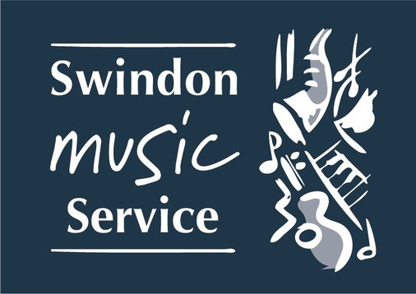
Swindon Music Service – Charitable Incorporated Organisation (CIO) No: 1179203 Swindon Music Service, The Platform, Faringdon Road, SWINDON SN15BJ
AIMS: (See examples)
Our aims include: (See examples)
TEL: 07395887191
E-Mail: lhawkins@smscio.co.uk Website: https://www.smscio.org

S C H O O L S I N G I N G S T R A T E G Y
At [
] School we believe that ALL children should have access to good quality singing
opportunities every week. We believe that singing is a truly inclusive musical activity that transcends all economical and academic boundaries and that it has a huge benefit on the wellbeing of our children.

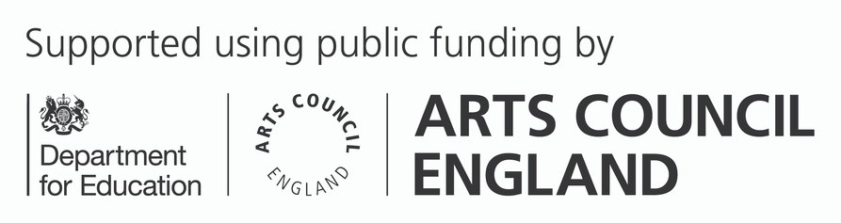

In a variety of styles: upbeat, slow, lyrical, powerful etc.

Our school will engage further in singing:
The school will aim to showcase their singing through participating:
Using the following resources:

Events:
Extra curricular groups

Acknowledge Challenges and Plans for Development

